

TED UNIVERSITY

Faculty of Engineering

Department of Computer Engineering

**CMPE 399 – Summer Training Report**

by

Abdullah Yağız Özbek

ETİ MADEN İŞLETMELERİ GENEL MÜDÜRLÜĞÜ

Internship Date (from 17/06/2019 to 02/08/2019)

Submission Date 26.11.2019

1 Table of Contents

2 Introduction…………………………………………..…....2

2.1 Overall Goal………………………….......................2

2.2 Expected Learning Outcomes……………..………..2

3 The Company Information……………………….………..2

3.1 General…………………………………….………..2

3.1.1 Historical Background………………….……2

3.1.2 Engineering Units……………………………2

3.2 Products and Services………………………………3

3.3 Work Environment…………………………………3

4 Assigned Tasks and Projects………………………………3

4.1 Problem definition………………………………….3

4.2 Knowledge Information……………………………4

4.2.1 Knowledge Integration with Course Work….4

4.2.2 Learned Tools and Technologies…………….4

4.2.3 Self Learning…………………………………4

4.3 Work Plan and Timeline…………………………….5

4.4 Implementation………………………………………5

5 Conclusion and Recommendations…………………………10

6 References…………………………………………………..10

2 Introduction

2.1 Overall Goal

Computer engineering was a dream of mine from a long ago and I always interested in computers. All the things we see in computers are created from 1 and 0’s and it always amazed me, that’s why I love being a computer engineer. Now, Artificial Intelligence technology is rising and that is the area I want to focus on and I want to do research about “Is is possible to give machines emotions and will ?”

2.2 Expected Learning Outcomes

I expect to be part of a project so that I can learn how real life projects are made.ETİ Maden is using SAP system for 3 years now and I want to learn about the language ABAP and what exactly is SAP.I want to join a formal meeting.

3 Company Information

3.1 General

Company name: ETİ Maden İşletmeleri Genel Müdürlüğü

Adress:Ayvalı Mah, Halil Sezai Erkut Cad/ Afra Sok. 1/A, 06010 Keçiören/Ankara

Supervisor:Yazılım Yönetim Birim Sorumlusu Necmettin Çelik

ncelik @etimaden.gov.tr

3.1.1 Historical background

After the declaration of Turkish Republic, with support of Gazi Mustafa Kemal Atatürk, mining businesses was start. With some configurations in 1998 these mining businesses took the name Eti Holding A.Ş. and again with some configurations in 2004 Eti Holding A.Ş. changes it’s name to ETİ Maden İşletmeleri Genel Müdürlüğü.

Eti maden has the world’s 73% percent of the boron reserves and the company’s biggest vision is to sell boron to the International Markets with it’s full potential.

3.1.2 Engineering Units

For 3 years Eti maden and Havelsan are working together to establish SAP system to Eti maden.

SAP ERP is an enterprise resource software developed by the German company SAP SE. SAP ERP incorporates the key business functions of an organization. The latest version (SAP ERP 6.0) was made available in 2006. The most recent Enhancement Package (EHP8) for SAP ERP 6.0 was released in 2016.

Business Processes included in SAP ERP are Operations (Sales & Distribution, Materials Management, Production Planning, Logistics Execution and Quality Managements), Financials (Financial Accounting, Management Accounting, Financial Supply Chain Management), Human Capital Management (Training, Payroll, e-Recruiting) and Corporate Services (Travel Management, Environment, Health and Safety, and Real-Estate Management).

3.2 Products and Services

Eti Maden is now selling the product BORON which is a washing powder.

3.3 Work Environment

Every room have one air conditioning and inside each room there are 3 to 4 employees (sometimes more). Every floor have one head of department and one manager. In each floor there are 3 elevators, one only takes command from odd numbered floors (floor 1,3,5,7), other one from even numbered floors and the third elevator is for general managers. After 5 p.m. every elevator works in every floor because it is day over.

4 Assigned Tasks and Projects

4.1 Problem Definition

I was assigned to the software management unit department and the focus of this department was finding errors in SAP system and solving the problems with Havelsan and other responsible companies. My training experience took place in software section. Other than software section there are database, hardware and cyber security. Database section responsible from maintaining servers and giving access to the related sections of the department. Hardware section responsible from counting the devices and maintenance of the devices. Cyber security section responsible from cyber security of the company. Software section responsible from managing projects running by the company, right now software section focused on solving the problems in SAP system.

In the first week of my internship software section proposed me a project which is an order site for ordering foods, teas and coffees. Employees giving their orders from phone and the problem is employees of the ETİ Maden love to drink tea and coffee so there is traffic and they do not give individual orders, if one employee wants to order something he/she ask every employee in the room so order is long and it causes confusion to the workers. Order site was the solution because you can prevent order traffic and detailed orders will be easy to prepare by the workers. I was alone in this project so everything implemented by me and this way I learned many things.

4.2 Knowledge Information

4.2.1 Knowledge Integration with the course work

Every web site requires a data base so, with my knowledge from relational data base course I was able to create the data base of the web site.

When you give a order your order is put into a queue and first order will leave the queue first so, this structure knowledge comes from my data structures and algorithms course.

4.2.2 Learned Tools and Technologies

Web service is half learned, I tried to write a web service for the web site because the workers make transactions with a portable device since they can not give up on using that devices there should be a web service between the workers device and the web site but the company did not let me.

Javascripts AJAX is learned, AJAX is a function that lets client to send request to the server and gets response from it, and it makes your web site more dynamic because it prevents the web page reload to see new updates on the page.

What is SAP is about is learned and the language ABAP is a little learned. What I found is that learning ABAP is not enough to understand SAP system. It is more related with the Industrial engineering since SAP is used for controlling everything about a company. ABAP is not a object oriented language but you can write functions. It is used for data base implementations and creating user interfaces.

Javascripts JQUERY library learned. It’s purpose is to write less, do more. It helped me to implement events for the web site.

How to make WAMP apache server public is learned (making your server accessible by other devices.). It is done by opening the config file and adding the IP address of the machine.

RFID is learned. It is a technology for reading the chip with laser technology from relatively far away.

4.2.3 Self learning

First 2 weeks of my internship, I focused on learning ABAP language. Other weeks I focused on my project.

4.3 Work Plan and Timeline

This is how I implemented my project piece by piece

|  |  |  |  |
| --- | --- | --- | --- |
| Task | Start | End | Duration |
| Deciding on the requirements of the project | 18/06/2019 | 21/06/2019 | 4 days |
| Design | 24/06/2019 | 28/06/2019 | 5 days |
| Client-side implementation | 01/07/2019 | 14/07/2019 | 2 weeks |
| Worker-side implementation | 15/07/2019 | 21/07/2019 | 1 week |
| Testing | 21/07/2019 | 01/08/2019 | 12 days |
| Presentation | 02/08/2019 | 02/08/2019 | 30 minutes |

4.4 Implementation

In this project I used WAMP, PHP , Javascript and MySQL. I implemented database by WAMP’s apache server and MySQL.

Menu:

Table of product list.

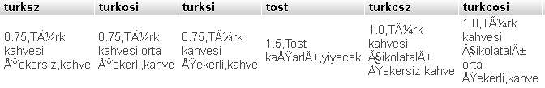

Poor implementation, elements of the order list added by columns, it should had been added by rows. Columns are the ids of the items and inside the row there are price, summary and type of the product which are separated with comma. It is used to create order menu in the website.

Website menu interface:

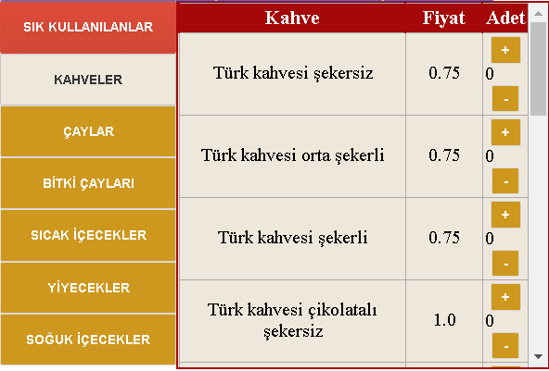

Web site interface designed for Windows and IOS and it works in every browsers. Resizing of the page when changing device to device or zooming in and out is implemented (For example, smart phones.) without the use of Bootstrap.

Favorites:

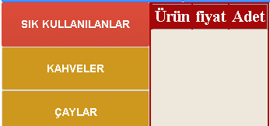

It’s empty right now because there is no order had been given before. It keeps the favorite products as cookies and first 5 most ordered products are shown on the “SIK KULLANILANLAR” section. We find the most ordered products by keeping how many products had been ordered for each of them.

Employees:

Table of the employees:

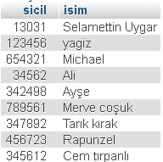

“sicil” no’s are used for log in. For employees I was designing something more detailed but they did not find necessary so I did not implement it.

Web site login screen:

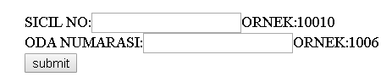

If sicil NO is wrong it gives an error. After the login “oda numarası” used to where to hand in the order and “sicil no” is used to confirm transaction.

After the login:



Name of the employee and room number are shown in top-left of the screen. User can change the room no.

Stock control:

Table of stock

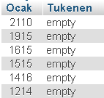

If an item was ran out from specific floor, then it’s id will be on “Tukenen” column. “Empty” means all products are available. When an item is ran out of stock, it’s id will be seen in the “Tukenen” column and if there are more items that ran out, they will be separated by comma.

Payment history:

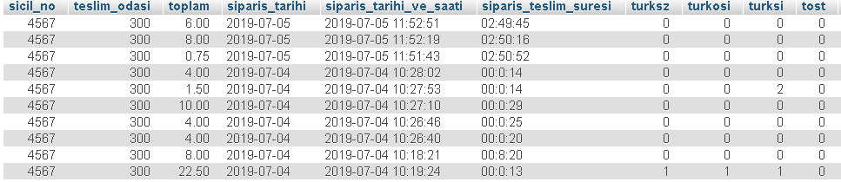

It keeps the price of the order and what is ordered. Also there is “siparis_teslim_suresi” column which is keeps the time between when it is ordered and when it is received by the employee. Every end of the month, employees receive monthly cut from the orders they gave and payment history is used to give them a report.

Current orders:

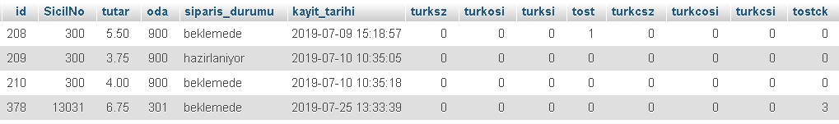

This table holds the current orders, this table is used to create the menu for workers that are responsible from the orders. Every “Ocak” is responsible from specific floors. Thus, workers will not see the orders that they are not responsible from. Every order has 2 situation which are “beklemede”, “hazırlanıyor” and “güncelleniyor”. If an order is in “beklemede” that means, employee that ordered that order can cancel or update the order. When an order is being updated, that order can not be interacted with the workers. When an order is in “hazırlanıyor” situation, that order neither can be cancelled nor updated. Workers can change the situation of the order to “hazırlanıyor”.

Workers can also can make some updates on the menu which is the stock control. When an item has ran out of the specific “Ocak” they can mark that item as “tükendi”. When an item is marked as “tükendi” that item can not be ordered by the employees on that floor. They can also make the item available again.

Administration side:

Admin can add, remove and update an item. When admin adds, removes or updates an item it can be directly seen by the workers and the customers since it is implemented by AJAX.

Errors that are fixed before the presentation:

1. When an employee updates an item, the order situation is changed as “güncelleniyor”. The problem while the order is being updated, employee can click to close or go back. When this is occurs, order is left as “hazırlanıyor” and it can not be interacted by both worker and employee. Thus, I implemented a event that whenever browser is closed while updating a order the order is again updates it’s condition as “beklemde”.
2. Whenever workers hit the button “hazırla” which changes the order’s situation to “hazırlanıyor” and employees hits the button “sipariş iptal” or “güncelle” at the same time, it caused some logic errors. How it is fixed is that whenever a worker or employee hits the button, responsible php files checks the order if it is changed or not. Thus, whenever an employee clicks the button “sipariş iptal” or “güncelle” although order is in “hazırlanıyor” situation, it gives an error message to the employee and request is gets cancelled. Same goes for the workers.
3. Whenever an item is marked as “tükendi” it effects current orders that are have that item. It is fixed by some limitations to the workers and employees. Workers can not press the button “hazırla” and employees have to cancel or update the order.

Future plan:

Future plan was the current coffee orders counter. Which counts the current coffee orders and shows the number to the employees so that employees can decide whether order or not order the coffee since coffee machines have some limits so it can take some time to deliver the order.

5 Conclusions & Recommendations

My recommendations for this company is to increase the capacity for intern students because work space was so limited and I had to change my work place many times.For more, even though the project I developed, they did not give me any other task than that, they could give me other tasks also.So, ETİ Maden should encourage the intern students to work more.

While I looking for companies to apply, I realized that most of the companies want knowledge about the webservices because most of the companies work with each other and they use webservices to achieve machine to machine communication and I am certain after the internship I did.So, my recommendation for TEDU CMPE Engineering is that CMPE students should take mandatory course about “Web” itself not the “web design” and the course should have homeworks for every topic about the Web.

6 References

Info about SAP.(Access date:2019, November 10). Retrieved from <https://www.sap.com/turkey/index.html>